ACSL
American Computer Science League
2013 - 2014

Contest #1

Senior Division

1. Recursive Functions
Find (16) given:
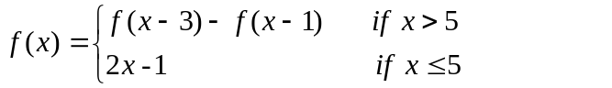

- Recursive Functions
Find ( ( (13) ) ) given:

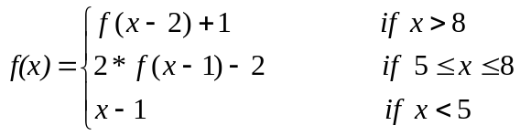
3. Computer Number Systems
Solve for X₁₆:

2₁₀ * X₁₆ – 464₈ = 11101110₂ – X₁₆

4. Computer Number Systems
What is the next integral decimal number after 328₁₀ to have the substring 0110 appear in its binary representation ?

- Assembly Language
What is the final value of E when the program is run?
A DC 10 T LOAD A P LOAD A
B DC 2 SUB D SUB B
C DC 5 BE U STORE A
D DC 8 V LOAD A BU R
LOAD A DIV B S LOAD B
SUB B ADD C ADD C
BG P MULT D STORE B
R LOAD B STORE E BU T
MULT C LOAD E U LOAD D
SUB D PRINT E SUB D
BL S END STORE D BU V

